[cambly.com/en/student/courses/5fa1de81b728c84f4ccaaa2f](https://www.cambly.com/en/student/courses/5fa1de81b728c84f4ccaaa2f)



## notes

|  |  |  |  |  |
| --- | --- | --- | --- | --- |
| coal /kəʊl/  gas  fossil fuel /ˈfɒsl/ /ˈfjuːəl/  e.g. The **fossil fuel** can generate electricity continuously. | | Wind power, wind farm  Water power  Solar power, solar panel /ˌsəʊlə ˈpænl/  Kinetic energy /kɪˈnetɪk/ change the kinetic energy to electric energy  e.g . The **clean/green energy** depend on the weather to generate electricity, so its way is discontinued.  e.g . The Three Gorges Dam uses the height difference of the river to generate electricity. | | |
| volcanic eruption  /vɒlˈkænɪk/ /ɪˈrʌpʃn/  lava /ˈlɑːvə/ | | frankie goes to hollywood  the power of love  queen  freddy mercury | | Nuclear power  That is a strong power and be difficult to control. |
| Wind day, rain day, storm day  Still day = sun day | |  | | Battery /ˈbætəri/  charge  recharge  He charged the car. |
| James Webb Space Telescope | |  | |  |
| to generate |  | | to produce | |
| To consist of | /kənˈsɪst/ | | To be made of / include | |
| Cell | /sel | | A container that holds the materials used to create electricity (e.g. a battery cell, a solar cell) | |
| layer | /ˈleɪə(r)/ | | A piece of material that covers the top or bottom of sth. | |
| Field |  | | Sth. That occupies space and has energy (e.g. magnetic field, an electric field) | |
| To conduct | /kənˈdʌkt/ | | To allow heat or electricity to move through something | |
| occupy | /ˈɒkjupaɪ/ | | keep busy with  occupy in | |
| silicon | /ˈsɪlɪkən/ | | silicon steel 硅钢  silicon rubber 硅胶 | |
| photovoltaic | /ˌfəʊtəʊˌvɒlˈteɪɪk/ | | producing a voltage when exposed to radiant energy (especially light) | |
|  |  | |  | |

|  |  |  |
| --- | --- | --- |
| magnetic | /mæɡˈnetɪk/ | Magnetic field ; mag-ne-tic |
| gravity  gravitational | /ˌɡrævɪˈteɪʃən(ə)l/ | Earth’s gravitational field |
| atom | /ˈætəm/ | protons /ˈprəʊtɒn/ 电子  electrons,  neutron /ˈnjuːtrɒn/ 中子 |
| dust |  | the furniture was covered with dust |

|  |  |  |  |
| --- | --- | --- | --- |
| Word part | con- | gen- | -sist |
| Meaning | together, with | give birth | to stand |
| Examples | conduct /pass/link  consist / include  concise / brief /kənˈsaɪs/  concern / worry  convince / believe | generate | consist / include  insist / hold on |
|  |  |  |  |

1. Solar panels consist of many smaller units ~~that are~~ called photovoltaic cells.
2. There is an increasing number of solar panel ~~that are~~ being installed.
3. They set up a solar array consisting ~~that consists~~ of ten panels.

## Slide

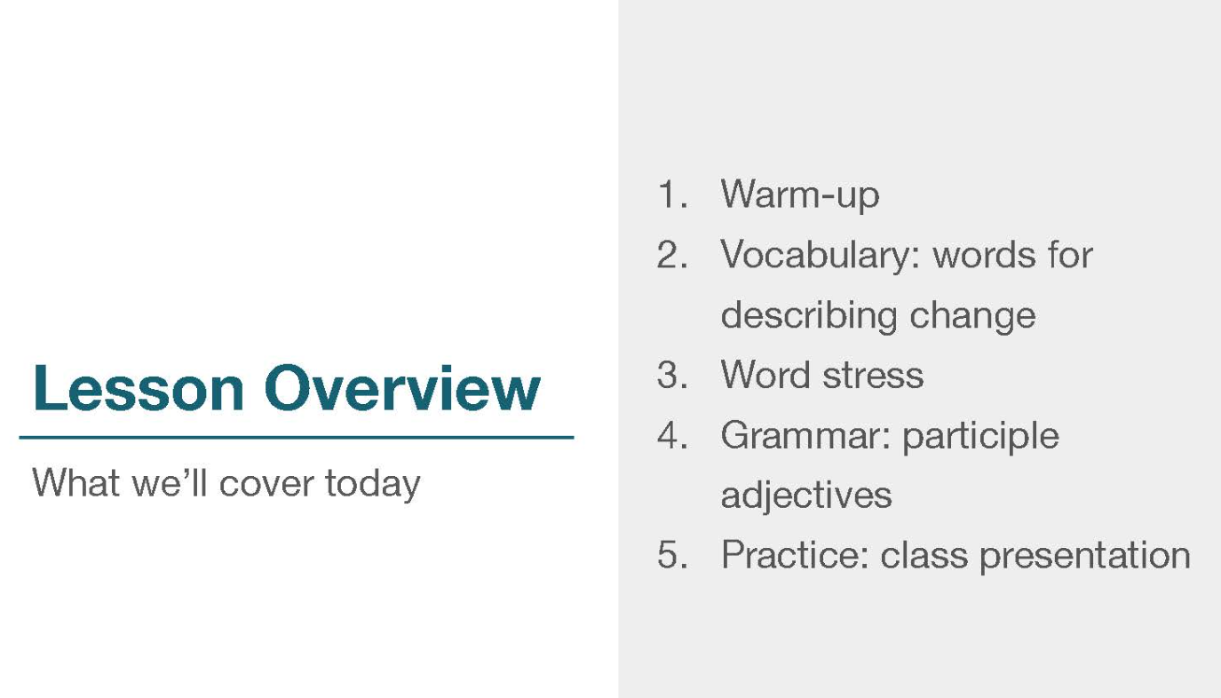

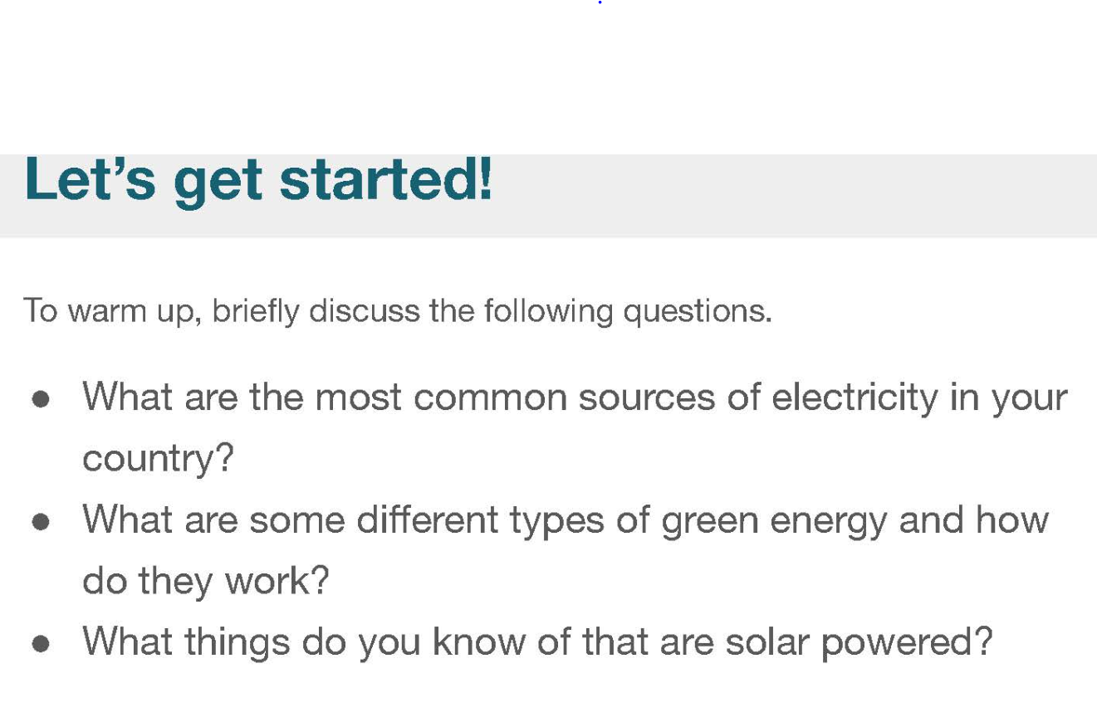

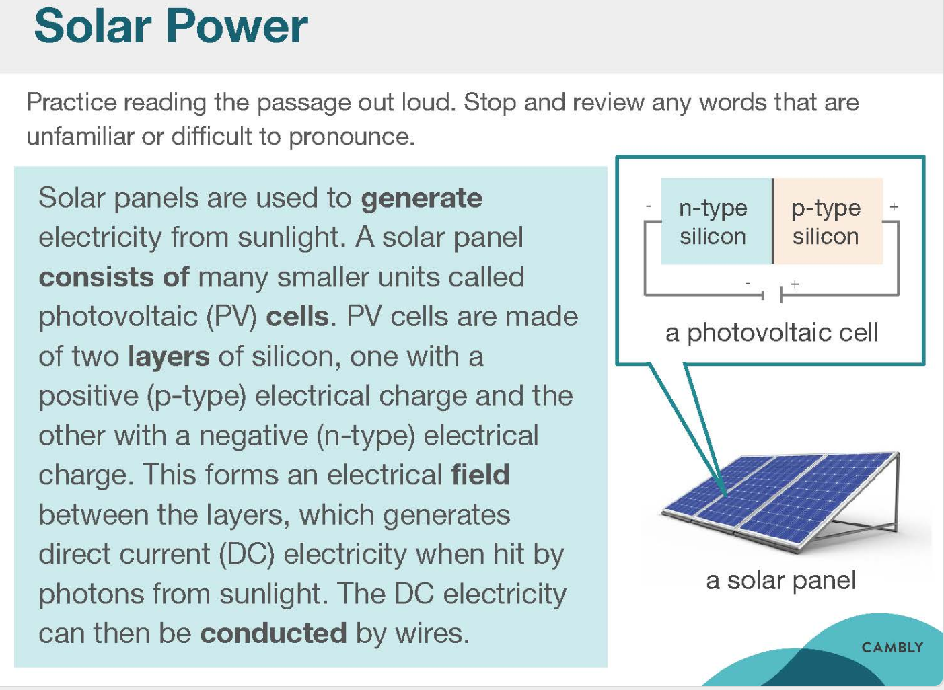

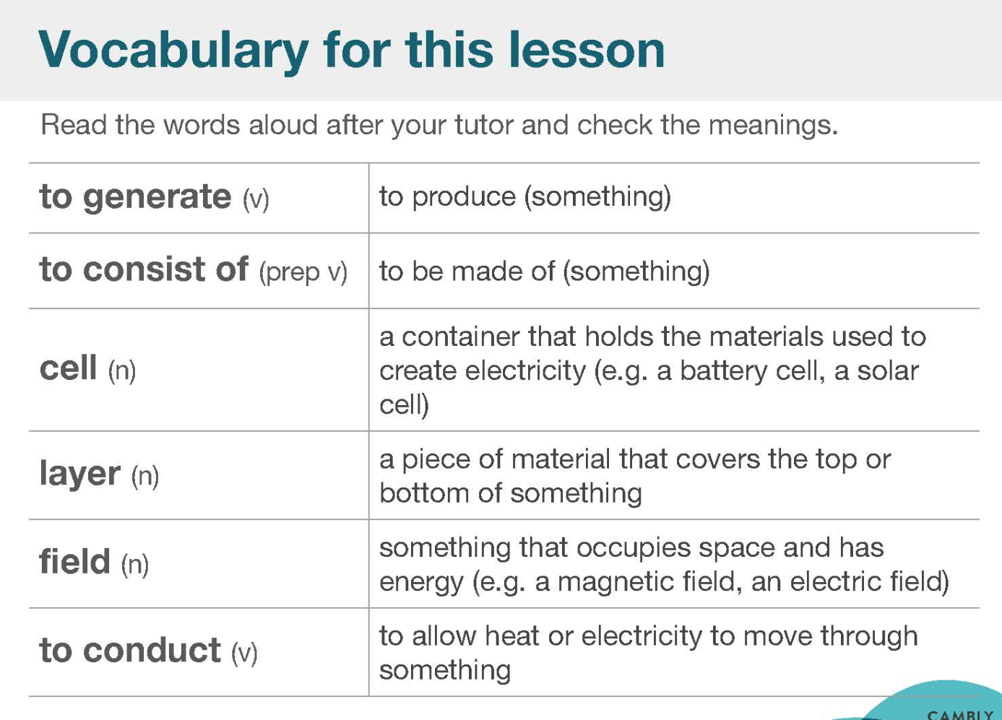

|  |  |  |
| --- | --- | --- |
| to generate |  | to produce |
| To consist of | /kənˈsɪst/ | To be made of / include |
| Cell | /sel | A container that holds the materials used to create electricity (e.g. a battery cell, a solar cell) |
| layer | /ˈleɪə(r)/ | A piece of material that covers the top or bottom of sth. |
| Field |  | Sth. That occupies space and has energy (e.g. magnetic field, an electric field) |
| To conduct | /kənˈdʌkt/ | To allow heat or electricity to move through something |
| occupy | /ˈɒkjupaɪ/ | keep busy with  occupy in |
| silicon | /ˈsɪlɪkən/ | silicon steel 硅钢  silicon rubber 硅胶 |
| photovoltaic | /ˌfəʊtəʊˌvɒlˈteɪɪk/ | producing a voltage when exposed to radiant energy (especially light) |
|  |  |  |

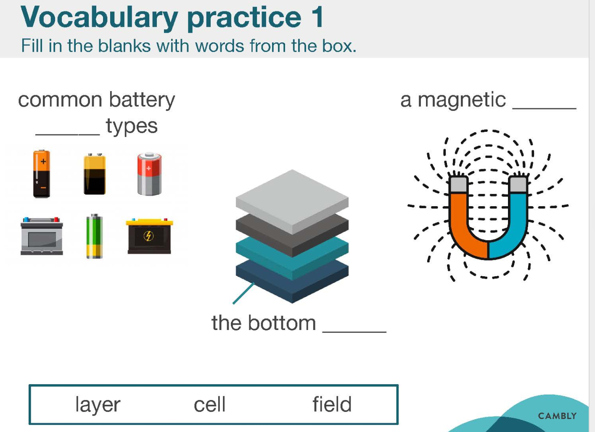

|  |  |  |
| --- | --- | --- |
| magnetic | /mæɡˈnetɪk/ | Magnetic field ; mag-ne-tic |
| Gravity  gravitational | /ˌɡrævɪˈteɪʃən(ə)l/ | Gravitational field |

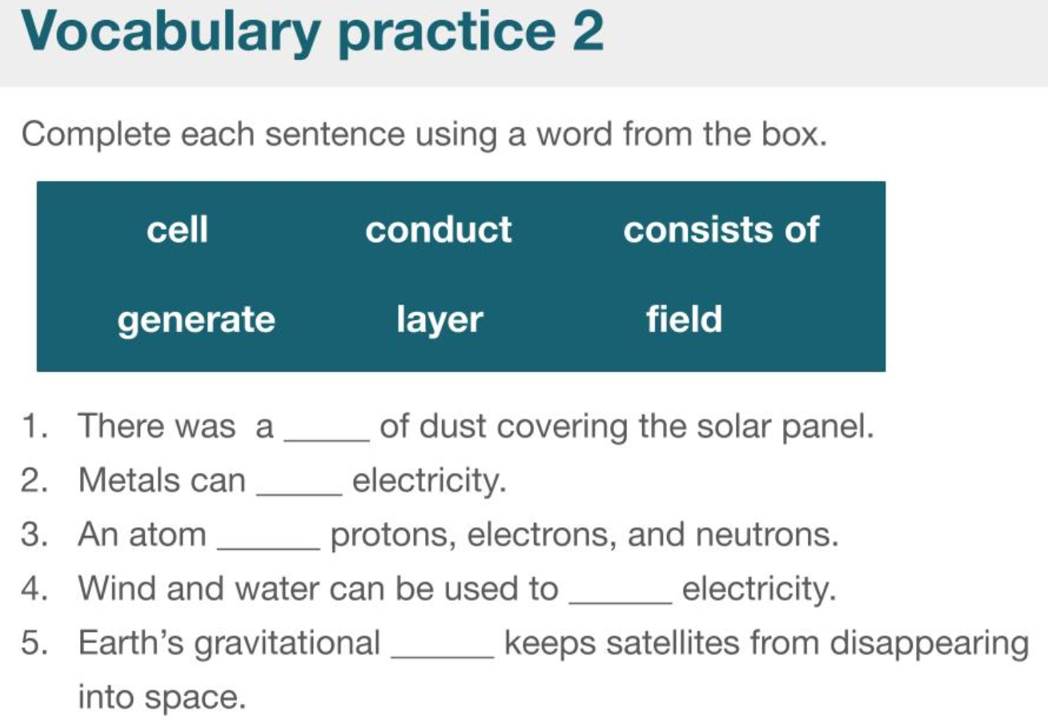

|  |  |  |
| --- | --- | --- |
| magnetic | /mæɡˈnetɪk/ | Magnetic field ; mag-ne-tic |
| gravity  gravitational | /ˌɡrævɪˈteɪʃən(ə)l/ | Earth’s gravitational field |
| atom | /ˈætəm/ | protons /ˈprəʊtɒn/ 电子  electrons,  neutron /ˈnjuːtrɒn/ 中子 |
| dust |  | the furniture was covered with dust |

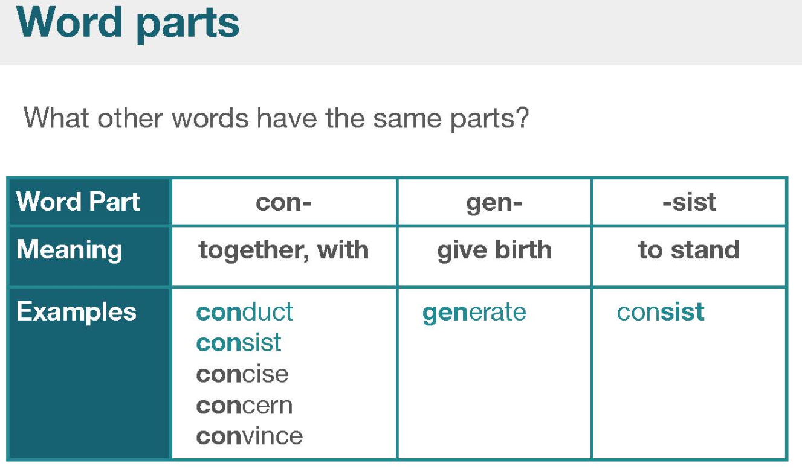

|  |  |  |  |
| --- | --- | --- | --- |
| Word part | con- | gen- | -sist |
| Meaning | together, with | give birth | to stand |
| Examples | conduct /pass/link  consist / include  concise / brief /kənˈsaɪs/  concern / worry  convince / believe | generate | consist / include  insist / hold on |
|  |  |  |  |

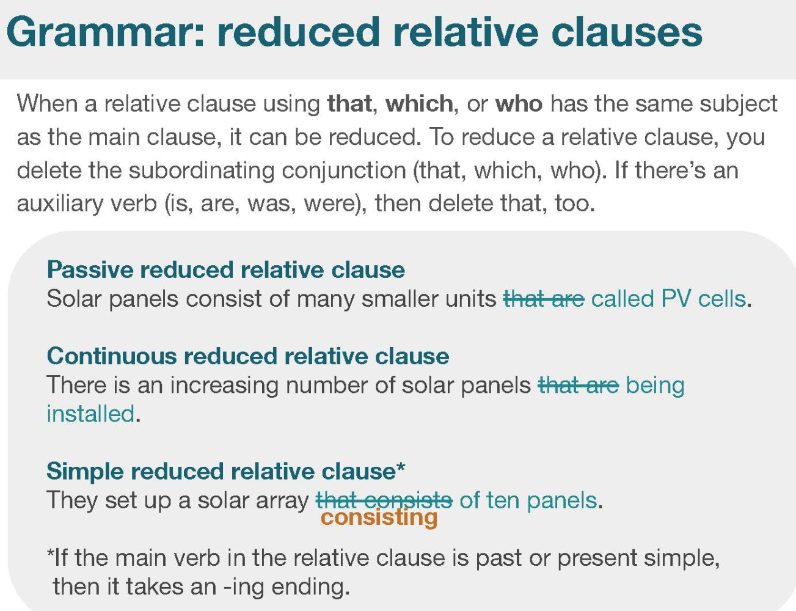

1. Solar panels consist of many smaller units ~~that are~~ called photovoltaic cells.
2. There is an increasing number of solar panel ~~that are~~ being installed.
3. They set up a solar array consisting ~~that consists~~ of ten panels.